# Data Visualizations of Crime Datain the City of Los Angeles

# 

# Vidhyasagar Janga vidhyasagarjanga@lewisu.edu DATA-53000, Summer 2021

Data Visualization Lewis University

# Introduction

The City of Los Angeles has maintained a continuous collection of crime data spanning from 2020 to the present. This extensive dataset serves as a comprehensive record of reported crime incidents, providing valuable insights into the dynamics and trends of criminal activities within the city. In this report, we employ various data visualizations to analyze the dataset and uncover potential correlations between different data attributes and customer satisfaction levels of airline passengers. Our objective is to present the data attributes in an informative and accessible manner, enabling readers to gain a comprehensive understanding of crime patterns and support informed decision-making for enhancing public safety and security in the City of Los Angeles.

# Data Description

The Crime Data from 2020 to Present in the City of Los Angeles is a comprehensive dataset containing 717,700 instances. These incidents are identified by unique report numbers (DR_NO) and occurred at various times throughout the day, with an average time of occurrence of 1,334.38. The crimes are distributed across 21 different areas within the city, with central area of Los Angels having the highest frequency of reported crimes. Most of the crimes fall under Part 1 offenses, which are more serious, while a small percentage are classified as Part 2 offenses. This dataset provides valuable information about various crime incidents that have occurred in the city The dataset includes records of both male and female victims, with ages ranging from 5 to 120 years. The dataset also has information about whether a weapon was used during the commission of the crime. It provides insights into the presence of weapons in criminal incidents. Overall, the Crime Data from 2020 to Present in the City of Los Angeles provides a comprehensive view of criminal activities in the city. Analyzing this dataset can help law enforcement agencies and researchers understand crime trends, identify high-crime areas, and develop strategies to enhance public safety in Los Angeles.

1. Data Attributes

|  |  |  |  |
| --- | --- | --- | --- |
| **Attribute** | **Description** | **Type** | **Value** |
| DR_NO | Division of Records Number | Plain Text | 10304468 |
| Date Rptd | Date reported | Date & Time | 01-08-2020 00:00 |
| Date Occ | Date occurred | Date & Time | 01-08-2020 00:00 |
| Time Occ | Time occurred in 24-hour military time | Plain Text | 2230 |
| Area | Geographic Area Identifier | Plain Text | 3 |
| Area Name | Name of the LAPD Geographic Area | Plain Text | Southwest |
| Rpt Dist No | Reporting District Identifier | Plain Text | 377 |
| Part 1-2 | Indicator for type of crime | Number | 2 |
| Crm Cd | Crime Code | Plain Text | 624 |
| Crm Cd Desc | Crime Code Description | Plain Text | BATTERY - SIMPLE ASSAULT |
| Mocodes | Modus Operandi | Plain Text | 0444 0913 |
| Vict Age | Age of the victim | Plain Text | 36 |
| Vict Sex | Gender of the victim | Plain Text | F |
| Vict Descent | Descent Code of the victim | Plain Text | B |
| Premis Cd | Premises Code | Number | 501 |
| Premis Desc | Premises Description | Plain Text | SINGLE FAMILY DWELLING |
| Weapon Used Cd | Weapon Used Code | Plain Text | 400 |
| Weapon Desc | Weapon Description | Plain Text | STRONG-ARM (HANDS, FIST, FEET OR BODILY FORCE) |
| Status | Case Status | Plain Text | AO |
| Status Desc | Status Description | Plain Text | Adult Other |
| Crm Cd 1 | Crime Code 1 | Plain Text | 624 |
| Crm Cd 2 | Crime Code 2 | Plain Text | 988 |
| Crm Cd 3 | Crime Code 3 | Plain Text | 812 |
| Crm Cd 4 | Crime Code 4 | Plain Text | 624 |
| LOCATION | Street address of crime incident rounded to the nearest hundred block to maintain anonymity. | Plain Text | 1100 W 39TH PL |
| LAT | Latitude | Number | 34.0141 |
| LON | Longitude | Number | -118.2978 |

# Methodology and results

The data was input into Tableau, and multiple visualizations were created to conduct exploratory visualizations on the data. The below bar chart showing the total crimes in different areas of the city helps us see where crime is more or less frequent. The chart has bars that represent each area, with the height of each bar showing the number of crimes in that area. This makes it easy to compare the crime levels between areas. By looking at the chart, we can quickly see which areas have more crime and which areas have less. It helps us understand the differences in crime rates across the city and allows decision-makers, police, and communities to focus their efforts on areas with more crime. The chart can also reveal any patterns or concentrated areas of criminal activity in the city.

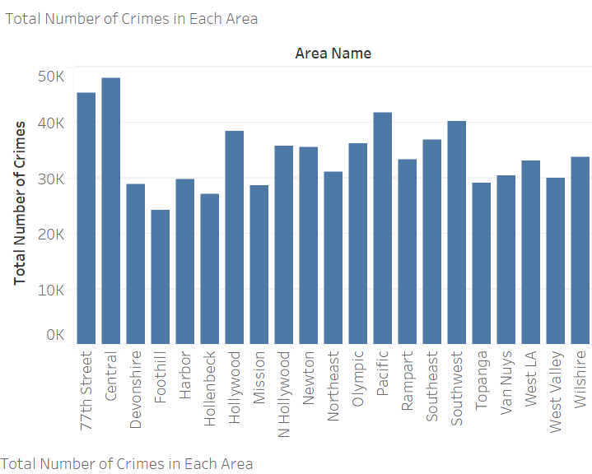

Fig. 1 Area vs Total Crimes

In Fig. 2, the below bar chart shows the total number of crimes based on different investigation statuses, such as "Adult Arrest," "Adult Other," "Investigation Continued," "Juvenile Arrest," and "Juvenile Other." The chart helps us compare the occurrence of crimes and the status of the crime visually. Each bar represents an investigation status, and its height indicates the number of crimes associated with that status. By looking at the chart, we can easily see which statuses have more or fewer crimes. This information is useful for policymakers, law enforcement agencies, and researchers to understand the distribution of crimes based on investigation status. 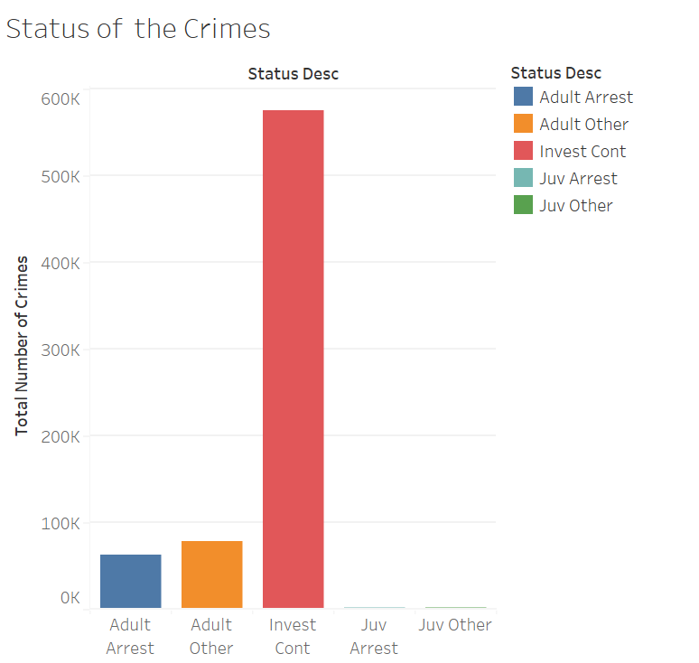

Fig. 2 Crime Status vs Total Crimes

In Fig. 3, the below line chart showing the total number of crimes each month gives a clear picture of how crime changes over the year. The chart has months on the horizontal axis and the count of crimes on the vertical axis. The line connects the data points, showing how crime levels go up or down over time. By looking at the line chart, we can easily see if crime is increasing, decreasing, or staying the same throughout the year. This helps police, policymakers, and analysts understand the seasonal patterns in crime and make plans accordingly. It also helps identify months with higher or lower crime rates, which can guide targeted actions and community involvement to address specific issues.

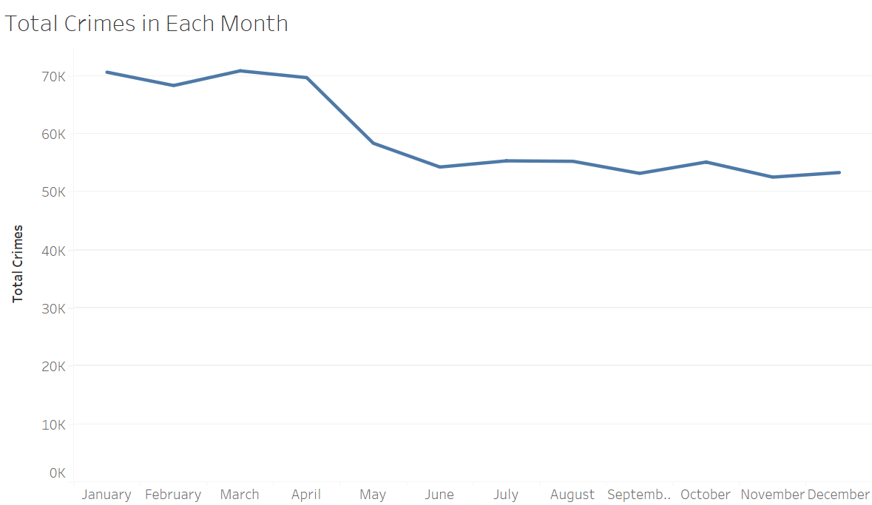

Fig. 3 Monthly Crimes

In Fig. 4, In the below pie chart depicting the distribution of the top 5 weapons used in crimes, it is worth noting that Heckler and MAc11 are identified as the highest and lowest used weapons, respectively. The sector representing Heckler would be the largest, indicating its significant prevalence in crime incidents. On the other hand, the sector representing MAc11 would be the smallest, indicating its comparatively lower involvement in criminal activities. This information is crucial for law enforcement agencies and policymakers to understand the specific weapons that are most prevalent and least prevalent in criminal incidents.

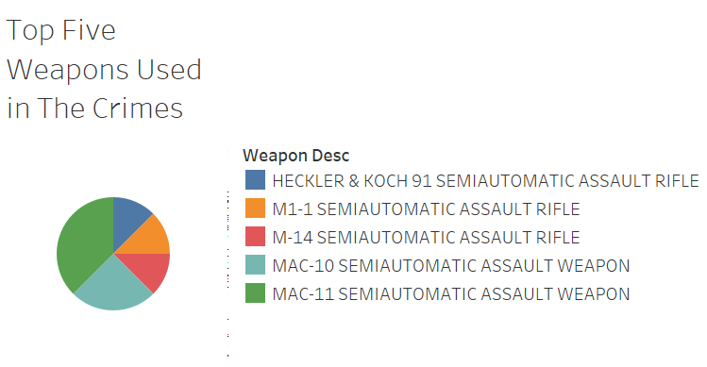

Fig. 4 Top five weapons used in the crimes

In Fig. 5, the below treemaps chart showing the top five crime categories, including vehicle stolen, theft of identity, battery, vandalism, and burglary, provides a visual representation of these crimes based on their frequency and impact. Each category is represented by a bubble on the chart, with the size of the bubble indicating the relative number of occurrences for that crime category. The chart allows for easy comparison of the sizes of the map, highlighting the crime categories with the highest frequency. It provides a quick understanding of the most prevalent and impactful crimes, such as vehicle theft, identity theft, physical assault, property damage through vandalism, and unlawful entry through burglary. This visualization aids in identifying the major crime categories of concern and can assist law enforcement agencies, policymakers, and communities in prioritizing resources and implementing targeted strategies to combat these crimes.

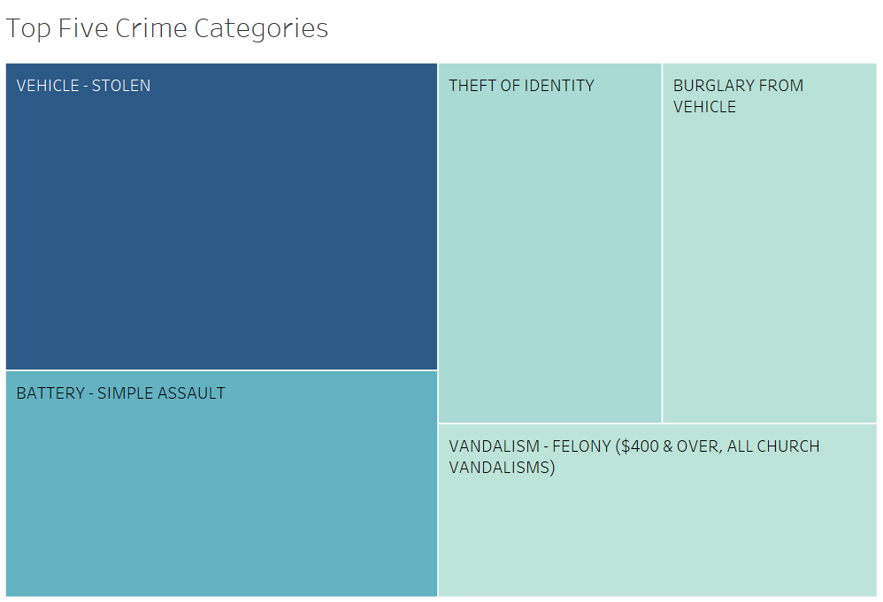

Fig. 5 Top five crimes in the city of Los Angeles

# Discussion

In our analysis, we used different visualizations to understand crime patterns in Los Angeles. By looking at the chart showing total crimes in different areas, we could identify high-crime areas and allocate resources accordingly. We also explored the chart depicting crime status, which helped us understand the progress of investigations and prioritize law enforcement efforts. Examining the top five weapons used in crimes gave us insights into common types of weapons involved. Analyzing the top five crime categories, including vehicle theft, identity theft, battery, vandalism, and burglary, helped us identify prevalent crimes and plan targeted prevention measures. Finally, the monthly crimes chart revealed any seasonal variations in crime rates, allowing us to allocate resources and plan law enforcement operations effectively. These visualizations provided valuable information for policymakers and law enforcement agencies to address crime and ensure public safety.

# Conclusions

In conclusion, our analysis of crime data in Los Angeles using various visualizations has provided valuable insights. We identified high-crime areas, observed the distribution of crime statuses and weapon usage, and determined the top crime categories. Additionally, we examined the variations in monthly crime rates. These findings inform law enforcement and policymakers, enabling targeted interventions, resource allocation, and improved crime prevention strategies.

##### References

[1] Crime Datain the City of Los Angeles: [https://data.lacity.org/Public-Safety/Crime-Data-from-2020-to-Present/2nrs-mtv8.](https://data.lacity.org/Public-Safety/Crime-Data-from-2020-to-Present/2nrs-mtv8.%20)